Software Requirements Specification   
–

Document ID: ASP-CMS-SRS-02.doc

Author: Diwakar A S

Version: 0.2

Date: April 7, 2024

1. Objective and Scope 3

2. Project End Users 3

3. Features 4

3.1 Login to the system 4

3.2 Add/Edit User 4

3.3 Checkout... 4

3.4 Payment…. 4

3.5 Logout**…………………………………………………………………………………………….………..4**

**4.Architecture diagram…………………………………………………………………………………………..5**

**5.Use Case diagram..........................................................................................................6**

**6.Class diagram…………………………………………………………………………………………………….7**

**7.Sequence diagram………………………………………………………………………………………………8**

# Objective and Scope

The objective of automobile web page is to provide comprehensive and accessible information about various aspects of automobile industry. This includes but is not limited to vehicle specifications, reviews, comparisons, maintenance tips, industry news, and technological advancements. The primary goal is to cater to the needs of automotive enthusiasts, prospective buyers, and industry professionals by offering reliable, up-to-date, and engaging content.

The scope of the product includes the following basic features:

* Multimedia Content: The web page will incorporate multimedia elements such as videos, images, and interactive tools to enhance user engagement and comprehension of automotive topics.
* Accessibility and User Experience: Emphasis will be placed on ensuring the web page is user-friendly, visually appealing, and accessible across different devices and platforms, providing a seamless browsing experience for all users.
* Accessibility and User Experience: Emphasis will be placed on ensuring the web page is user-friendly, visually appealing, and accessible across different devices and platforms, providing a seamless browsing experience for all users.

# Project End Users

Those who use web applications to purchase automobile related hardware products.

# Features

## Login to the system

Each and every user should be authenticated with a User Name and Password to login into the system.

Validations for User Name and Password.

User Name: It accepts only Alphabets, Numbers, Dot (.) symbol and Underscore (_) symbol.

Password: It can be anything of the users’ choice.

## Add/Edit User

**Add User:**

Users are added into the database through the Add User page. Before adding the user, it allows the user to check for any duplicates in the database.

**Edit User:**

Users who are added through Add User page are saved into the database as a draft, which can be edited by Edit user page.

## Add to Cart

Each authenticated user can add the product to the cart for further payment process and checkout.

## Checkout

User can check for their products, delivery address and total amount for payment.

## Payment

User was sent to secured payment gateway for payment process. User can check the address

and expected date o delivery.

# Architecture Diagram

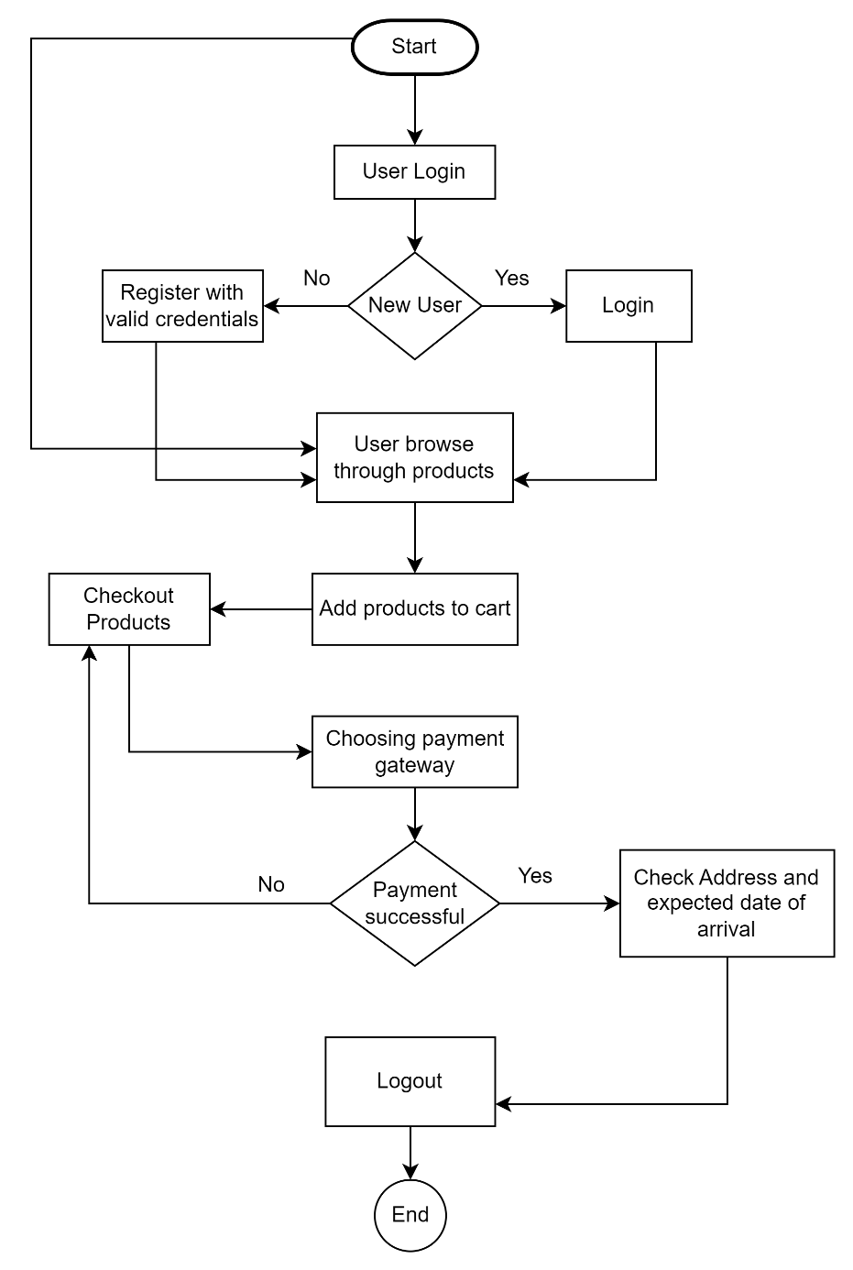

# Use case diagram

This use case diagram illustrates the connections between customers and administrators

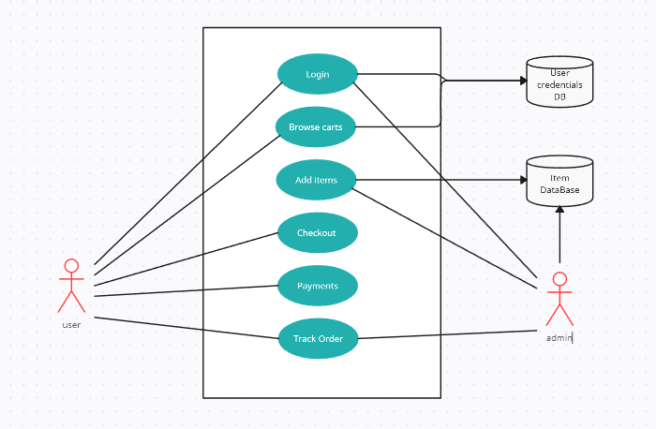

# Class Diagram

In this class diagram, the relationships between buyers and administrators are depicted.

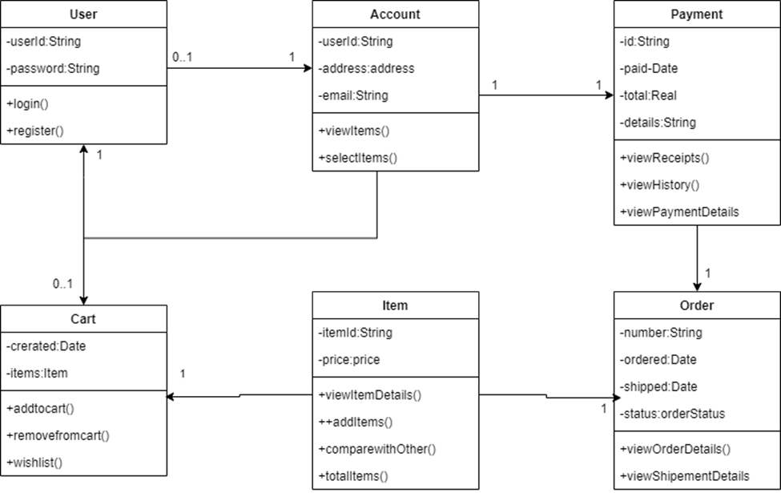

# Sequence diagram

In this sequence diagram, the interactions between buyers and administrators are illustrated.

